**Playful patriotism on Bilibili: an observation on how state propaganda apparatus adapts to and interacts with teenagers’ culture in China**

**Abstract**

Observing an increasing participation of official media and party committees on Bilibili, a popular online video platform among teenagers in mainland China, our research aims to understand how patriotic and nationalistic videos released by official accounts interact with the general audiences. By collecting 100 most popular patriotic videos published by official accounts and tracing whether these videos are imitating or imitated by other individual uploaders on the platform, we aim to understand how the community develop and react to patriotic video contents. Moreover, by further categorizing the style of videos and comparing the mode of interaction (the number of Danmaku) of the viewer and the uploader, we further explore whether the degree of playfulness of patriotic videos influence the interaction mode and the intensity of the response. Our research shows that, among all types of video contents, the videos on international affairs feature the highest extent of playfulness. Moreover, playful patriotism is an intentional advocacy of(from?) the state, while the common users remain conservative in expressing their political opinion (especially sarcasm) publicly. Therefore, though the playfulness may encourage the immediate and low-cost interaction such as like, share, and comment from the audience, it does not necessarily increase the likelihood that common users imitate and produce the videos released by official channels, which may also result from the mediation of other significant factors, such as the difficulty of imitation.

**Literature Review**

*Adapted Soft propaganda*

It is over-simplifying to regard Chinese state propaganda, a set of strategies with complex consideration, as a single project. Encountering dilemmas and trade-offs, there could be at least two types of propaganda, which corresponds to two different modes of public persuasion. The first type is **hard propaganda**, through which the authoritarian regimes propagandize as a signal to demonstrate their capacity of repression. As Huang (2015) points out, despite knowing that citizens would doubt the authenticity of state propaganda, the monopoly of the propaganda apparatus implies that the state’s strong capacity of promotion and mobilization, which further deters the potential dissents domestically.

If the first type of state propaganda refers to the coercive power of authoritarian regimes, the second type of propaganda is based more on **the legitimate power**. As Perry (2017) has argued, rather than merely showing the state's power which forces the citizens to comply, the state also aims to establish their “right to rule” among the citizens. While the hard propaganda deters citizens with the state's capacity, the soft propaganda is much more entertaining and emotionally resonant (Mattingly & Yao, 2021). For instance, the image of the Chinese Communist Party (CCP) as the successor and heir of the Chinese traditional spirit is present in various TV series, festival galas and patriotic songs. Moreover, by reiterating the humiliating history of the Sino-Japanese war, the Chinese government has constructed the image of CCP as the heroic figure who led China out of the abyss of poverty, political upheavals, and foreign invasions.

*Online propaganda, cyber nationalism, and* ***playful patriotism***

With the emergence of social media and the surge of Internet users in China, apart from censorship and distraction, Chinese government has actively participated in the “propaganda war” online. Not only has it dealt with the negative messages with censorship and distraction, but it has also established its own narrative about international affairs and used the screening algorithm as facilitation (King et al., 2017; Bolsover & Howard, 2019; Molter & DiResta, 2020).

Through traditional wisdom regards nationalism as a result of the state's unilateral propaganda program, Chinese cyber nationalism is oftentimes a bottom-up initiative (Zhao, 2004; Chen et al., 2021). In some platforms with abundant user-generated content (UGC), common users produce their own content with strong nationalistic inclination, which sometimes caused the nationalism backlash for Chinese government (Zhang et al., 2018).

Moreover, the cyber nationalism in China has a strong characteristic of playful patriotism. Referring to Chen et al. ’s (2021, p.111) definition, playful patriotism is a “state-endorsed but not necessarily orchestrated, light-hearted, and amusing” way to promote patriotism and nationalism on social media. However, since their analysis is mainly based on Douyin, the Chinese version of Tiktok, we will further explore how playful patriotism is presented in the case of Bilibili, which has a younger user population.

*A brief history of* ***Bilibili’s interaction with state propaganda apparatus***

Since the start of the 21th century, the Chinese government has imposed increasingly strict censorship on the online platforms and cultural industry. Bilibili, as the most popular video streaming website in the Chinese animation community, has been dealing with increasing regulative forces from authorities. In May of 2018, the Office of the National Work Group for Combating Pornography and Illegal Publications have penalized Bilibili for publishing contents that “harm social ethics”. Later in July of the same year, Bilibili was criticized publicly by CCTV for its “vulgar content and bad influence on teenagers”. The Cyberspace Administration of China also summoned executives and managers of Bilibili for a private meeting and ordered the company to rectify problems with its video contents.

Under tremendous pressure, Bilibili not only censored the contents of videos but also sought to join the mainstream political expression. For instance, starting from the end of 2017, Bilibili invested, produced and disseminated several animations promoting nationalism and patriotism, exemplified by Chinese Choir (中國唱詩班) and Year Hare Affair (那年那兔那些事).

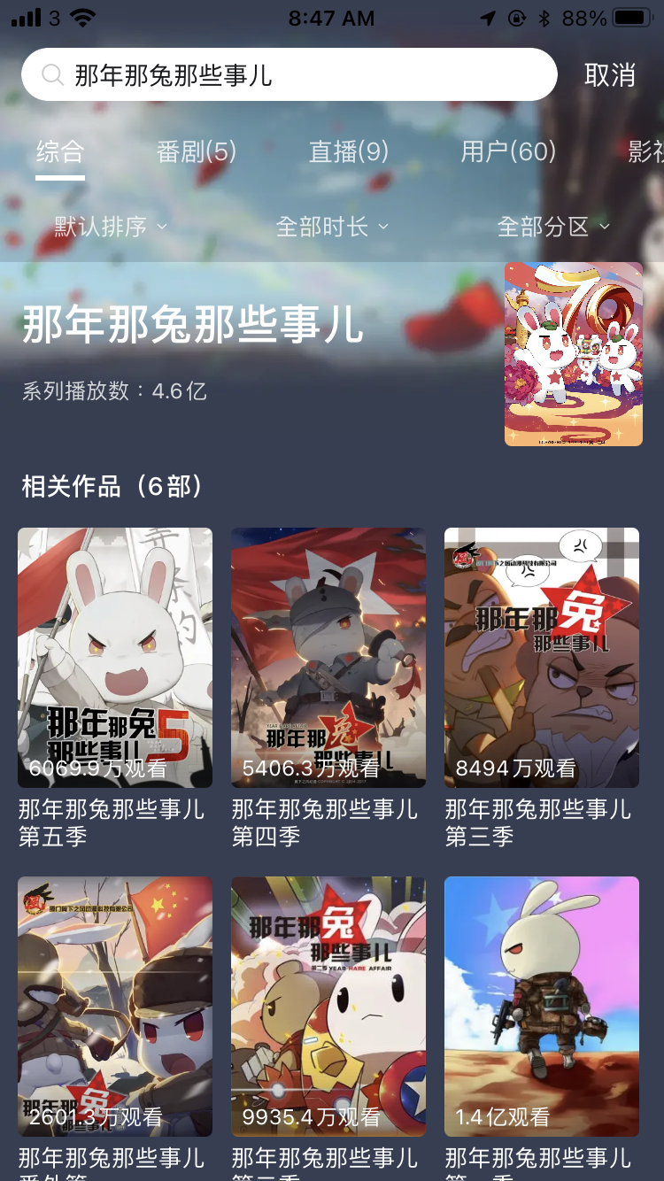 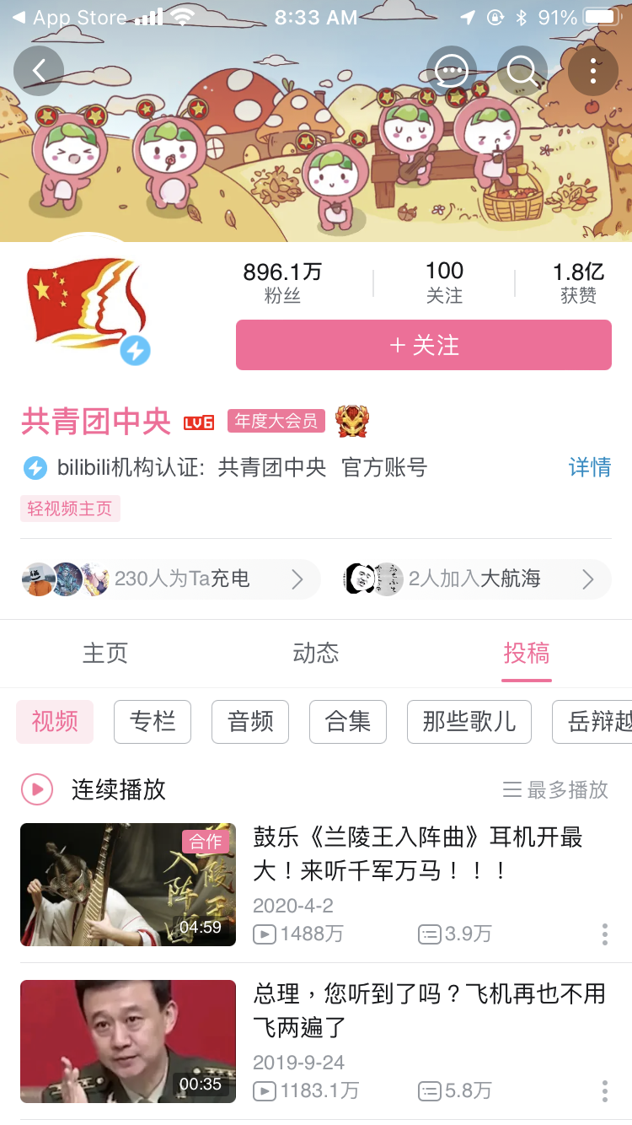

(Left: Screenshot of one of the most popular patriotic animations)

(Right: Screenshot of the CCCYL’s account page in Bilibili on October 10th, 2021)

*The establishment of official accounts in Bilibili*

While Bilibili was trying to align itself with the mainstream political values to ensure its survival, the state propaganda also realized the significance of Bilibili's influence among Chinese teenagers. At the end of 2016, the CCTV Documentary channel created its account in Bilibili, followed by CCTV Business Channel. In January of 2017, the Central Committee of the Communist Youth League (CCCYL) started its account in Bilibili in the name of "making friends with the younger generation." Unlike traditional official media, official accounts in Bilibili have quickly learned the language and expression of teenagers, adapted nationalistic messages with animations and sarcastic videos, and turned patriotic education and state propaganda into entertainment. When this article is written, the account of CCCYL has become the sixth most popular account across the entire platform, with 8.33 million followers. Official mouthpieces are continually expanding their influence and deepening collaboration with Bilibili. The online new year gala of Bilibili in 2019 was co-organized by Bilibili and Xinhuanet, one of the most prestigious official news outlets.

*Bilibili and Danmaku*

One of the most distinctive features of Bilibili is it’s Danmaku. Danmaku is the anonymous comments floating across the screen while the videos are played, which could be seen by other users together with the video content (Yin & Fung, 2017). The adoption of Danmaku makes the experience of video streaming in Bilibili especially interactive compared with other video platforms.

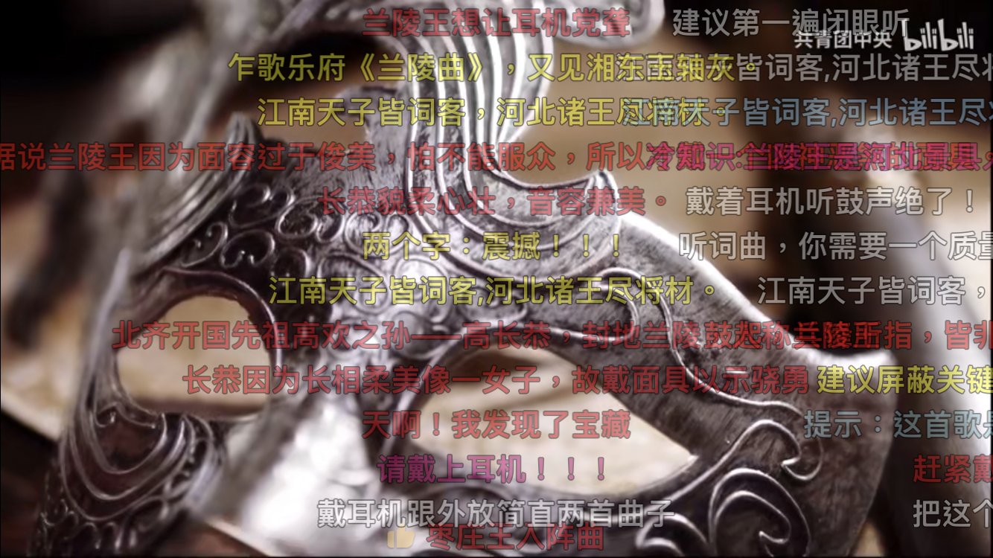

(Screenshot of Danmaku)

Compared with the traditional comments below the videos, the Danmaku comments play an extra role in reshaping the video contents. Wu et al. 's (2018) find that the viewer has participated in **developing and altering the other viewer’s experience** by providing unofficial translations of videos in foreign languages and sending hints of the forthcoming plots using Danmaku. Zhang and Cassany (2020) also showed that users use **quotations, repetitions, cultural references, and indirect sarcasm** as a response to the video content and other Danmaku comments, which influences the opinions on the video of later audiences.

### **Research Questions**

Based on previous studies, we are interested in the following three questions:

1) What is the general **mode of interaction** between the official account and the public in different types of nationalistic videos?

Both the official accounts and citizens on the platform simultaneously have two roles as a user: the content creator and the content consumer. Based on the different extent of commitment, the general modes of interaction between official accounts and mass users can be summarized in the following table.

|  |  |  |
| --- | --- | --- |
| **Categorization criteria for mode of interaction** | | |
|  | Official - original content | Official - reupload |
| Public - only Danmaku & comments  (Less commitment) | Official only | Bottom up |
| Public - Danmaku, comments, and video adaption  (More commitment) | Top down | bidirectional |

Moreover, based on the answer of the first question, we also aim to further answer the following two questions:

1. What is the relationship between **playful patriotism** and different categories of video content? Do the videos with playful patriotism have more interactive modes?
2. What is the relationship between the number of **Danmaku** (as an indication of degree of viewer interaction) and the categories of video content? Do the videos with playful patriotism gain more Danmaku?

Based on our previous analysis, our hypotheses for the Questions 2 and 3 are as follows:

H1: Videos with playful patriotism have more interactive models than the ones without it.

H2: Videos with playful patriotism have more Danmaku than the ones without it.

### **Methodology**

First, we identify the top 17 most popular accounts owned by official media outlets with over 400,000 followers on Bilibili, as shown in the table below.

|  |  |
| --- | --- |
| Types of official accounts | Name of the accounts |
| State-owned media | 央视新闻, 小央视频, 央视网快看, 观察者网, 央视频, 环球时报, 中国日报  (CCTV News, Xiao CCTV, CCTV Quick Watch, Observer, CCTV, Global Times, China Daily) |
| CCYL of different provinces | 共青团中央, 广东共青团, 浙江共青团, 河南共青团, 安徽共青团, 湖南共青团, 福建共青团, 四川共青团, 贵州共青团, 重庆共青团  (CCCYL, Guangdong CCYL, Zhejiang CCYL, Henan CCYL, Anhui CCYL, Hunan CCYL, Fujian CCYL, Sichuan CCYL, Guizhou CCYL, and Chongqing CCYL) |

Then we scrape the information of the top 100 most popular video contents uploaded by these official accounts from March 2019 to September 2021. The information of concern includes the video title, time of upload, the number of views as of Oct 10th 2021, the number of the Danmaku response.

Our decision to analyze videos with the highest views is backed by two reasons. Firstly, Bilibili recommends videos to users based on algorithms, with the videos with higher views more likely to be recommended to users who are not familiar with a certain type of content, thus further expanding the exposure. By choosing the videos with the highest views, we could control the influence of the platform exposure, and the differences observed are more likely to result from the video contents. Secondly, the interactions and comments of videos with the highest views usually make the interaction mode and viewer feedback more prominent compared to other videos of the similar content and style.

After selecting the top 100 video content, adopting the categorization from Bi (2020), we categorize the nationalistic videos into five categories below: she categorized all the nationalist and patriotic videos into six categories:

1) videos showing contribution and devotion to the country,

2) videos showing achievements of the country, such as technological development and sports award,

3) videos concerning the diplomatic issues, such as the territorial disputes, international relations, and political leaders of other states,

4) videos about Chinese history and traditional cultures, such as the veteran during WWII and the traditional festivals,

and 5) videos about ideological education, such as talks about Marxism and party leadership. To ensure consistency in categorization, we first randomly selected 20 videos to conduct a reliability test.

Two of our researchers categorized these 20 videos separately. Since the percentage of different judgments is more than 10 percent, we fail to pass the reliability test. Therefore, we conduct the rest of categorization collaboratively.

Then, to analyze their interaction mode, we will manually search for related videos by other users by using the keywords in the video titles. By searching for the videos with similar titles and contents released before and after the video, we summarize and code the interaction mode of each video.

With the dataset of the 100 videos selected, we will further manually categorize them into the two categories ofplayful and not playful. There are two reasons for us to treat playfulness and not playfulness as binary variables. Firstly, from the result of our primary research, the difference between videos of different tones is quite clear and obvious. Secondly, since we will use the association test to see whether videos with and without playful patriotism differ in their interaction mode, binary variables will facilitate our further test.

Finally, we will see whether the number of Danmaku differs from different categories of video, and run an association test to see whether there is a statistically significant difference between videos with and without playful patriotism on the number of Danmaku.

**Research result**

*Summary of categories and interaction mode*

As shown in the graph, among the 100 videos with the highest views in Bilibili, the ones getting the highest views are the videos concerning **international affairs**, which almost double the highest of other categories. If excluding the outliers of the international affairs category, the videos about culture, history, and ideology education gained relatively more attention than the ones about national achievements and national spirit.

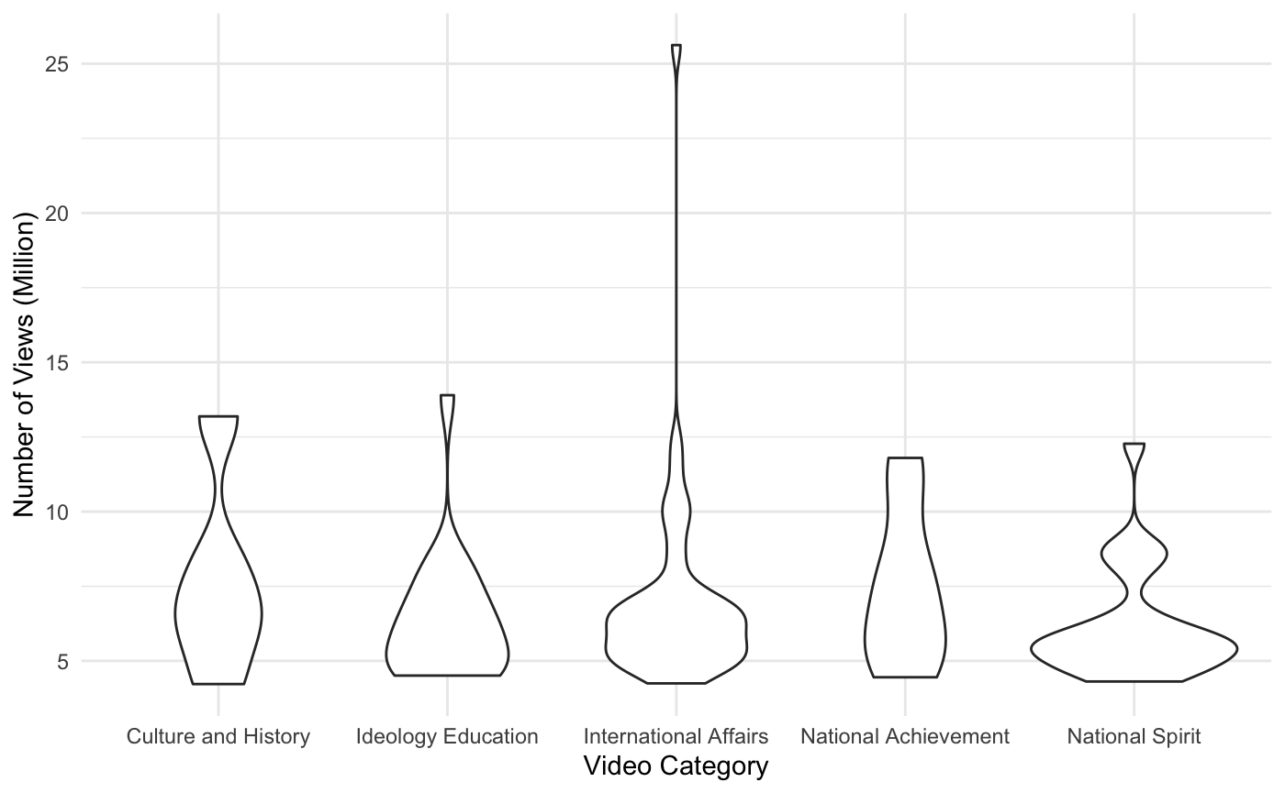

As for the relation between the video categories and the interaction mode, the figure demonstrates that a considerable number of professional users on Bilibili have been actively imitating the videos released from the official accounts. Among them, the videos about international affairs and national spirit are the two most imitated. Meanwhile, despite the major mode of interaction remaining unilateral, which means only official accounts are releasing videos with no previous or following videos, the figure also shows that there has been some learning and adoption of the official accounts from the common users in Bilibili. Among them, the most adopted and learned category is the videos about **national spirit**.

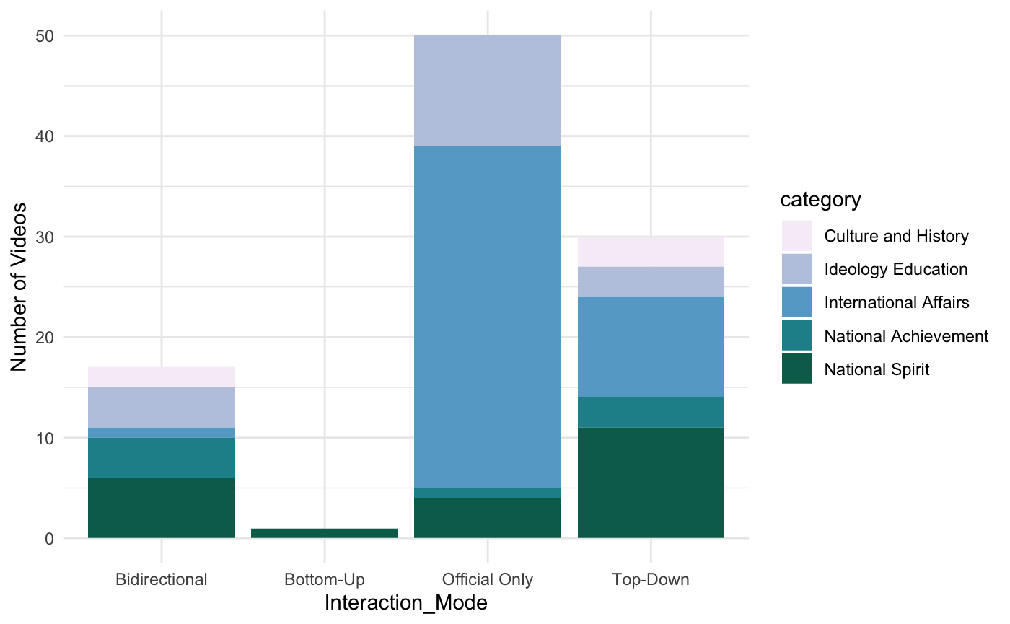

*Playfulness and different categories of videos*

Among the 100 videos collected, the majority of the videos are in a not playful tone. Meanwhile, as shown in the figure below, among the videos with playful patriotism, videos about international affairs compose the absolute majority, which is more than the sum of all other 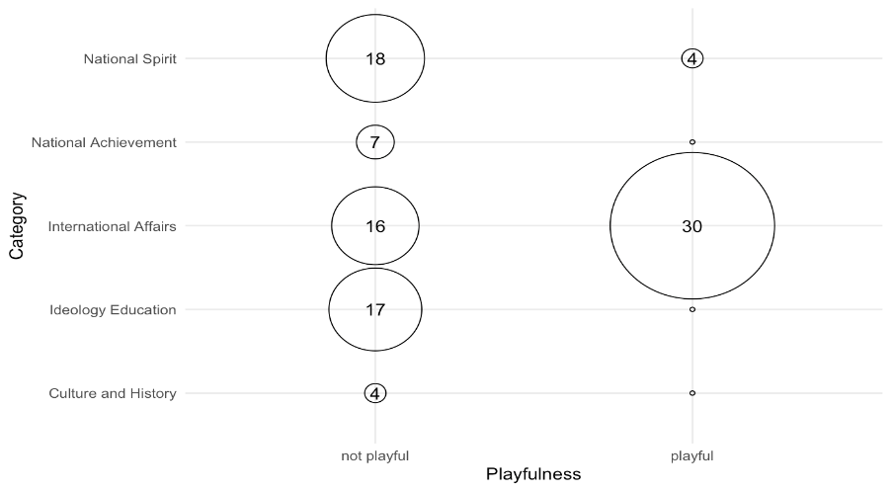categories.

The Chi-square association test between playfulness and category of content showed a significant difference between the categories in their playfulness level (n=99, df=4, p-value < 0.01).

*Playfulness and engagement, in forms of modes of interaction and Danmaku*

In the Chi-square association test between playfulness and interaction mode, an unexpected result was found. The playful videos are significantly more likely to have originated from and circulated among official accounts (n=99, df=2, p-value = 0.048), instead of attracting users to imitate (Top-Down mode), create (Bottom-Up mode), and interact (Bidirectional mode).

In the independent t-test, videos that are more playful do not show significantly more comments and Danmakus than the videos that are not playful, albeit having a larger variance. However, there are several possible explanations. The first is that not playful videos can elicit other kinds of strong emotions that encourage comments, such as a sense of pride, being moved, and hatred. Secondly, Danmaku on Bilibili can be erased for various reasons, when the uploader replaced the video source of the same site or when they choose to turn off the Danmaku function temporarily. Several videos concerning sensitive topics have abnormally few Danmaku, such as the one about the 70th anniversary of the country’s establishment.

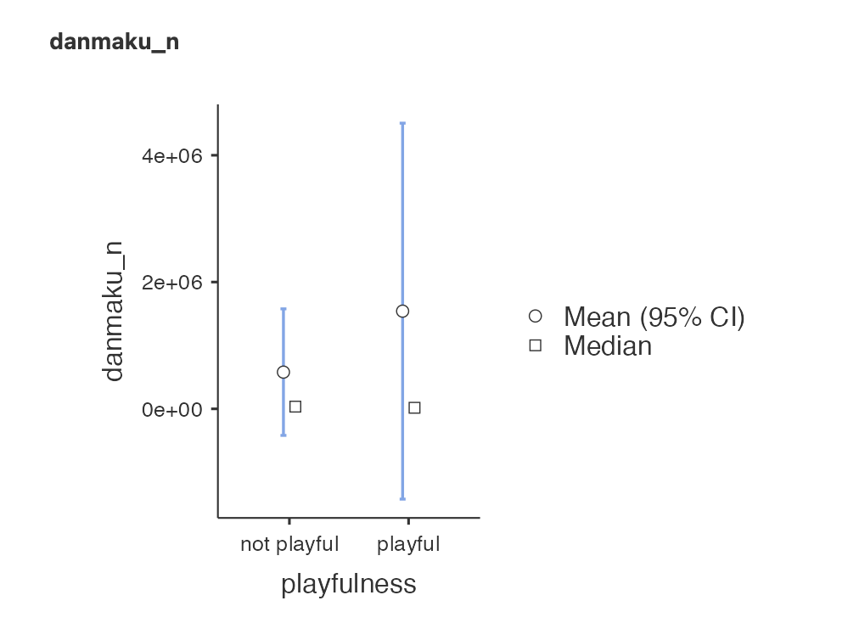

It seems that Hypothesis 1 is rejected. However, if we further look into the details of how modes of different extent of interaction correlate with playfulness, we could see that over half of the playful videos have the interaction mode with the least interaction, and the videos, if they do circulate, only circulate among official accounts. Moreover, in the rest of the playful videos, the dominant mode of interaction remains the top-down model, while the bidirectional and bottom-up model accounts for very little of it.

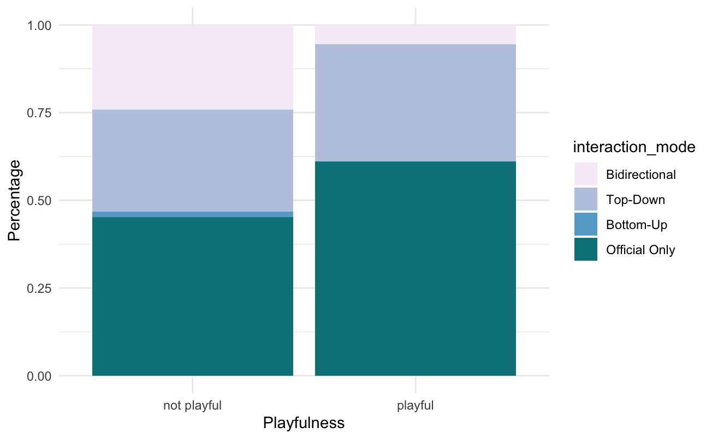

*Number of Danmaku, video categories, and playful patriotism*

Since Danmaku is largely related to the views of the video, we compose an index indicating the number of Danmaku to million views and see how it relates to different video categories. The equation of the index is as follows.

$$Danmaku_to_view = Log(\frac{Number of Danmaku}{Number of views (million)})$$

It turns out that the ratio of number of Danmaku of most nationalistic videos is within the range of 8 to 12. Three outliers are noteworthy. Firstly, few of the videos concerning international relations have a particularly heated reaction in Danmaku. Meanwhile, some videos on national achievement also gained massive responses. Finally, some videos about national spirit seem to have an unusually low response in Danmaku, which may relate to the censorship of the platform.

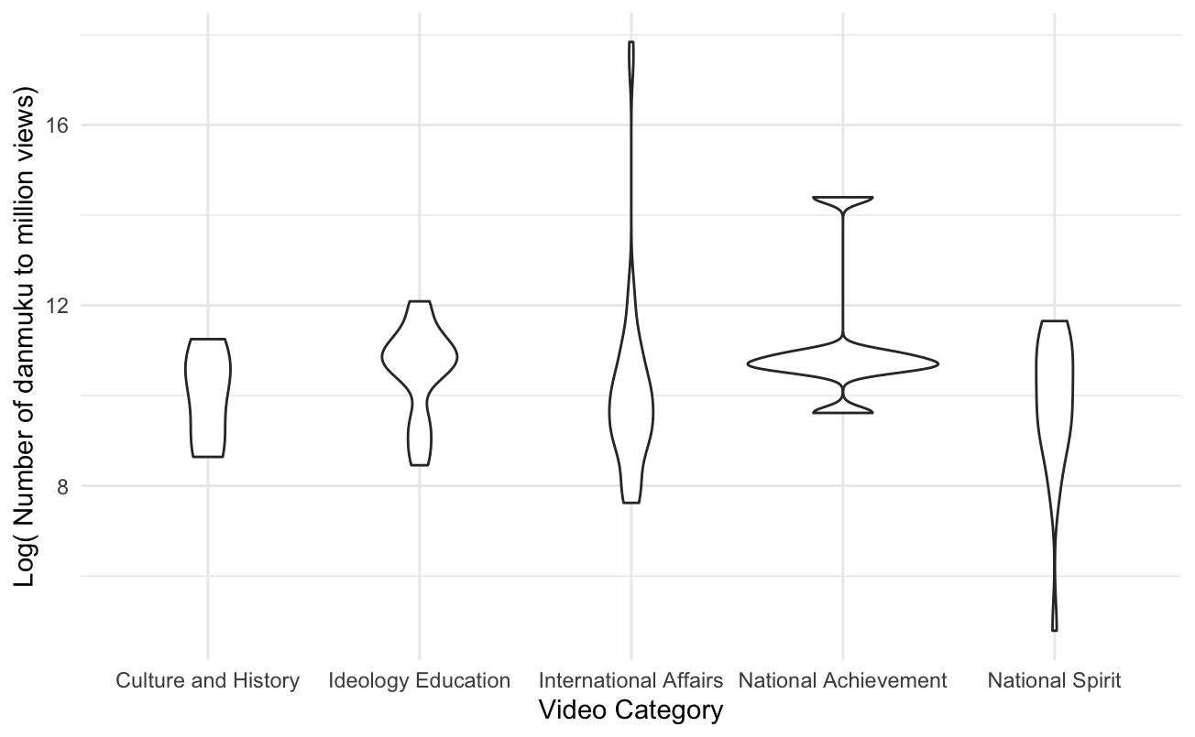

Despite the seeming correlation demonstrated in the plot graph, there is no significant relationship between the category of video content and the number of Danmaku, which defeats the H2.

**Discussion and limitation**

Based on our research result, it can be seen that the common users in Bilibili react and respond enthusiastically to the videos released by official accounts in Bilibili. Apart from their high participation rate in posting Danmaku comments, they actively imitated and re-created the videos of official accounts, which form the self-initiated regeneration of state propaganda. Different from the cyber nationalism which was mostly initiated by the grass root forces in China, the videos produced by the common users, as the imitation of official accounts’ videos, are indirectly guided and disciplined by the original videos, which decreases the likelihood of nationalism backfire.

Moreover, during the research, we found several personal accounts have specialized in re-uploading and re-creating the videos of official accounts due to the high views gained by the videos released by official accounts. In this sense, since the views could be transferred to money at a certain rate to the uploaders, the patriotism and nationalism in Bilibili have corresponded with the market values in Bilibili, which further promote the re-generation of patriotism from the common users. This partially explains why Bilibili has not developed as the prediction of Yin and Fung (2017). Observing the self-regulated, egalitarian, and well-organized community in Bilibili, they optimistically argue that Bilibili could be the start of democratization of the younger generation of China. However, referring to the previous introduction and the increasing nationalistic videos in Bilibili, it seems less likely that Bilibili would be a start of political democratization of China in the Cyber sphere. When nationalism corresponds with the market value, the democratic characteristics of this platform will exaggerate rather than alleviate nationalism. While emphasizing the democratic potentiality of the discussion procedure in Bilibili, Yin and Fung (2017) overlook that Bilibili and the algorithm of this platform remain profit-oriented.

However, from the side of official accounts, though adopting some videos from the common users, most of their videos aim to propagandize unilaterally. An essential implication is that, despite the seemingly active popular engagement in playful patriotism, the official accounts have always been the most active promoter of making nationalist and patriotic propaganda entertaining. In some cases, we observe that the official accounts, such as the accounts of CCYL of different provinces, would re-upload and copy each other’s videos, which forms a whispering wall of the official accounts and reinforces the strength of state propaganda. Moreover, the unusual little amount of Danmaku of some official videos with the adoption of the common users’ video has well corresponded with our understanding of propaganda, which is a dynamic process involving censoring the opposite voices, demonstrating its own strength, and promoting its own legitimacy.

Unlike expected, the playfulness, though having an impact on the views, does not necessarily increase the rate of imitation and re-production of official accounts’ videos. Three possible reasons may help explain this phenomenon. The first one is that there are other essential factors impacting reproduction. For instance, the accessibility of the original video could influence whether the common users are able to imitate or not. Since the common users could not access the first-hand videos, they could not further re-create the video.

Another factor which may also have an impact is the room for reproduction. Despite the low rate of imitation of videos in the international affairs category, one video mocking US president Joe Biden gained more than 1000 imitating and reproducing videos. In the original video, President Biden fell off three times when getting on the plane. This action gained such popularity because it is easy to add a context, while reproduction of video based on this short clip does not require delicate design and high technological skills. Therefore, the mockery of President Biden finally became a cyber carnival based on nationalism.

The final and probably the most significant reason could be the **self-censorship** of Chinese netizens. Though finding the videos playful, the audience may still realize that they themselves could not publicly comment or laugh at these figures while the official accounts can. Though the official account tries to signal the public with the playfulness of videos, the public remains conservative and careful in getting involved in expression and discussion on politics. This may explain why most of the playful videos are in the international affair category, while the imitation of this category remains limited.

Our research does have some limitations. Firstly, our definition of official accounts could be limited compared with reality. As Yuan (2020) points out, some official accounts of the higher education institutions, such as the official account of Tsing-Hua University, should also be considered as official accounts. Secondly, our database of Danmaku is not abundant enough for observation. And considering the platform would delete Danmaku from time to time, this may also affect our final result. Moreover, we did not have the chance to further explore other facets of Danmaku, such as the emotional sentiments or the extent of deliberation of it, which we invite future research to fill in the gap.

References:

Bi, K, Y. (2020). *The official expression of cyber patriotism under the two-dimensional shell.* Shandong Normal University.

Bilibili. (2021). *Annual Report of 2020.* Retrieved from: <https://ir.bilibili.com/static-files/98bfad59-0a57-467c-a3f4-e250c3bada4b> (Accessed on Oct. 2nd)

Bolsover, G., & Howard, P. (2019). Chinese computational propaganda: Automation, algorithms and the manipulation of information about Chinese politics on Twitter and Weibo. *Information, communication & society*, *22*(14), 2063-2080.

Chen, X., Valdovinos Kaye, D. B., & Zeng, J. (2021). # PositiveEnergy Douyin: constructing “playful patriotism” in a Chinese short-video application. *Chinese Journal of Communication, 14*(1), 97-117.

Diao, J, X. (2020). *Breaking through walls and fusion: mainstream discourse practice in the secondary culture.* Graduate School of Chinese Academy of Social Sciences.

Ford, C., Gardner, D., Horgan, L. E., Liu, C., Tsaasan, A. M., Nardi, B., & Rickman, J. (2017, May). Chat speed op pogchamp: Practices of coherence in massive twitch chat. *Proceedings of the 2017 CHI conference extended abstracts on human factors in computing systems* (pp. 858-871).

Guo, X., & Yang, S. (2016). The memetic communication and consensus mobilization in the cyber nationalist movement. *Chinese Journal of Journalism & Communication, 38*(11), 54–74.

Harris, P. (1997). *Chinese nationalism: the state of the nation.*

Huang, H. (2015). Propaganda as signaling. *Comparative Politics, 47*(4), 419-444.

King, G., Pan, J., & Roberts, M. E. (2017). How the Chinese government fabricates social media posts for strategic distraction, not engaged argument. *American political science review*, *111*(3), 484-501.

Liu, L., Suh, A., & Wagner, C. (2016). Watching online videos interactively: the impact of media capabilities in Chinese Danmaku video sites. *Chinese Journal of Communication, 9*(3), 283-303.

Mattingly, D. C., & Yao, E. (2021). *How Soft Propaganda Persuades.*

Molter, V., & DiResta, R. (2020). Pandemics & propaganda: how Chinese state media creates and propagates CCP coronavirus narratives. *Harvard Kennedy School Misinformation Review*, *1*(3).

Perry, E. J. (2017). Cultural governance in contemporary China: “Re-orienting” party propaganda. *To govern China: Evolving practices of power,* 29-55.

Wu, Q., Sang, Y., Zhang, S., & Huang, Y. (2018, January). Danmaku vs. forum comments: understanding user participation and knowledge sharing in online videos. In *Proceedings of the 2018 ACM conference on supporting groupwork* (pp. 209-218).

Yin, Y., & Fung, A. (2017). Youth online cultural participation and Bilibili: An alternative form of democracy in China? In *Digital media integration for participatory democracy* (pp. 130-154). IGI Global.

Yuan, M, Y. (2020). *"Two-dimensional nationalism" and the identification construction of mainstream ideology.* Shandong Normal University.

Zhang, L. T., & Cassany, D. (2020). Making sense of danmu: Coherence in massive anonymous chats on Bilibili. com. *Discourse Studies, 22*(4), 483-502.

Zhang, Y., Liu, J., & Wen, J. R. (2018). Nationalism on Weibo: Towards a multifaceted understanding of Chinese nationalism. *The China Quarterly*, *235*, 758-783.

Zhao, S. (2004). *A nation-state by construction: Dynamics of modern Chinese nationalism.* Stanford University Press.

Zhu, Y. (2011). “Performance legitimacy” and China’s political adaptation strategy. *Journal of Chinese Political Science, 16*(2), 123-140.